|  |
| --- |
| Lenguaje: Codext  Gramática libre de contexto (3)  Primera revisión |



**Árbol de derivación**

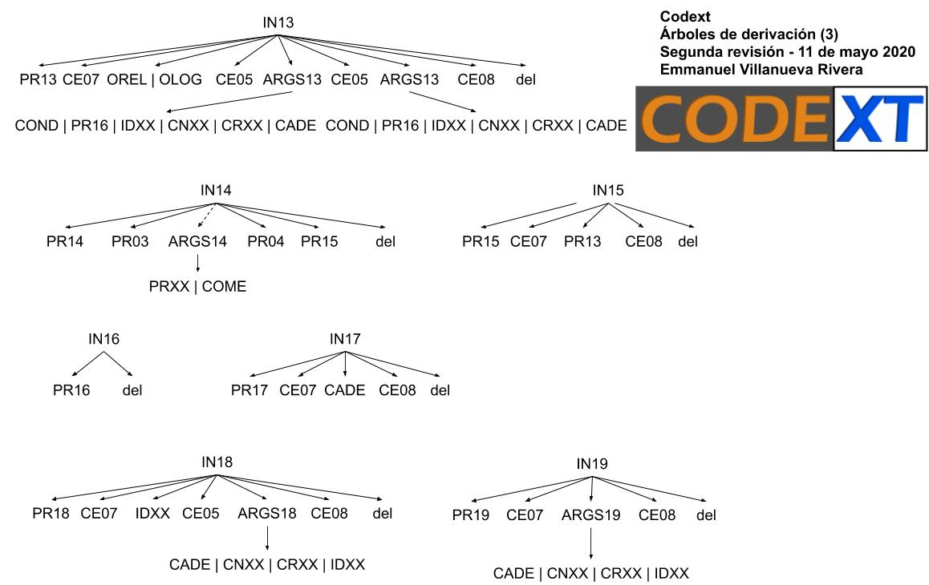

**Gramática libre de contexto**

|  |  |  |
| --- | --- | --- |
| Instrucción | Gramática | Recorrido bottom-up |
| IN13 | S 🡪 COND  COND 🡪 PR13 ce07 ARGS131 ce05 ARGS132 ce05 ARGS132 ce08  ARGS131 🡪 OREL | OLOG  ARGS132 🡪 COND | PR16 | IDXX | CNXX | cade | PR13 ce07 OPLN ce05 cade ce05 COND ce08  PR13 ce07 **OLOG** ce05 cade ce05 COND ce08  PR13 ce07 **ARGS131** ce05 cade ce05 COND ce08  PR13 ce07 ARGS131 ce05 **ARGS132** ce05 COND ce08  PR13 ce07 ARGS131 ce05 ARGS132 ce05 **ARGS132** ce08  **S** |
| IN14 | S 🡪 PR13 PR03 ARGS14 PR04 PR15  ARGS14 🡪 INST | come | PR13 PR03 come PRO4 PR15  PR13 PR03 **ARGS14** PR04 PR15  **S** |
| IN15 | S 🡪 PR15 ce07 PR13 ce08 | PR15 ce07 PR13 ce08  **S** |
| IN16 | S 🡪 PR16 | PR16  **S** |
| IN17 | S 🡪 PR17 ce07 cade ce08 | PR17 ce07 cade ce08  **S** |
| IN18 | S 🡪 PR18 ce07 IDXX ce05 ARGS18 ce08  ARGS18 🡪 cade | CNXX | CRXX | IDXX | PR18 ce07 id01 ce05 cn02 ce08  PR18 ce07 **IDXX** ce05 cn02 ce08  PR18 ce07 IDXX ce05 **CNXX** ce08  PR18 ce07 IDXX ce05 **ARGS18** ce08  **S** |
| IN19 | S 🡪 PR19 ce07 ARGS19 ce08  ARGS19 🡪 cade | CNXX | CRXX | IDXX | PR19 ce07 cr10 ce08  PR19 ce07 **CRXX** ce08  PR19 ce07 **ARGS19** ce08  **S** |

**Otras producciones del lenguaje**

INST 🡪 PR05 | PR06 | PR07 | PR08 | PR09 | PR10 | PR11 | PR12 | PR13 | PR14 | PR15 | PR16 | PR17 | PR18 | PR19  
OARI 🡪 OPAS | OPAR | OPAM | OPAD | OPAP | OPAC

OREL 🡪 OPRM | OPRm | OPRI | OPRD | ORMI | ORmI  
OLOG 🡪 OPLA | OPLO | OPLN  
CEXX 🡪 ce01 | ce02 | ce03 | ce04 | ce05 | ce06 | ce07 | ce08 | ce09 | ce10  
IDXX 🡪 id01 | id02 … | idn  
CNXX 🡪 cn01 | cn02 … | cnn  
CRXX 🡪 cr01 | cr02 … | crn